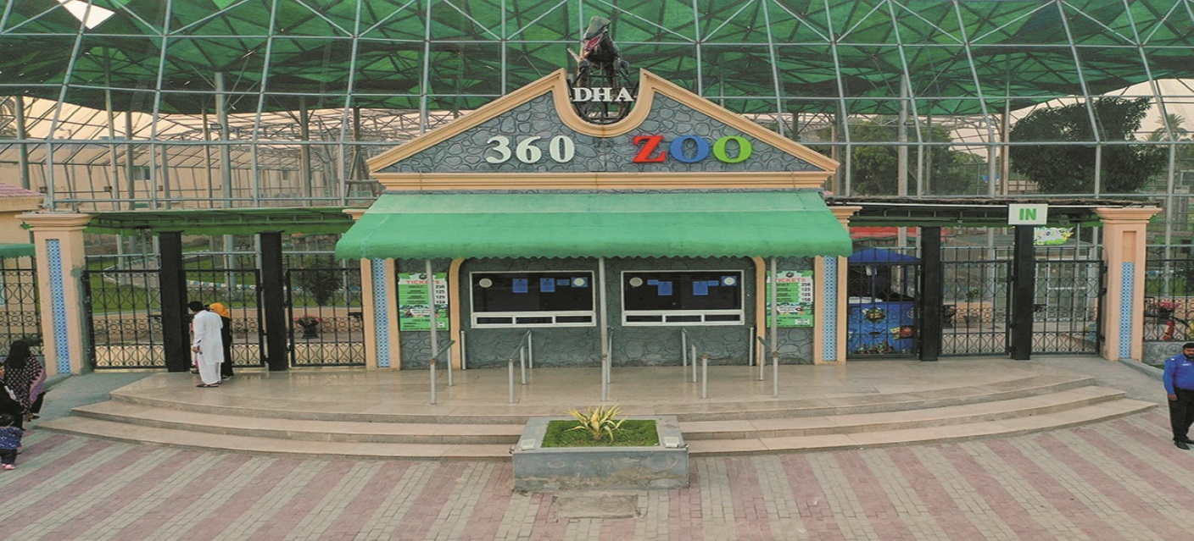

About Multan Zoo Park

What is Multan Park Zoo? and where is located established?

The Multan Zoo is a zoological park located in Multan, Pakistan. It is one of the prominent zoos in the Punjab province, designed for recreational purposes, wildlife education, and conservation. The zoo serves as a popular destination for families and tourists in Multan the zoo is situated in Multan, Punjab, Pakistan, near the Mumtazabad area, which is easily accessible from various parts of the city The Multan Zoo was officially established in 2008, making it relatively new compared to older zoos in Pakistan, like Lahore Zoo or Karachi Zoo.

Opening & Closed Timings

Opening Time: 9:00 AM To Closed 6:00 PM

The Multan Zoo does not have exclusive "ladies-only" or "family-only" timings. Families and individuals, including women, can visit during the zoo's regular hours. The zoo is generally family-friendly throughout its operational hours.

If you are looking for specific events or activities catering to women or families, it is advisable to contact the zoo administration directly, as such initiatives are announced occasionally.

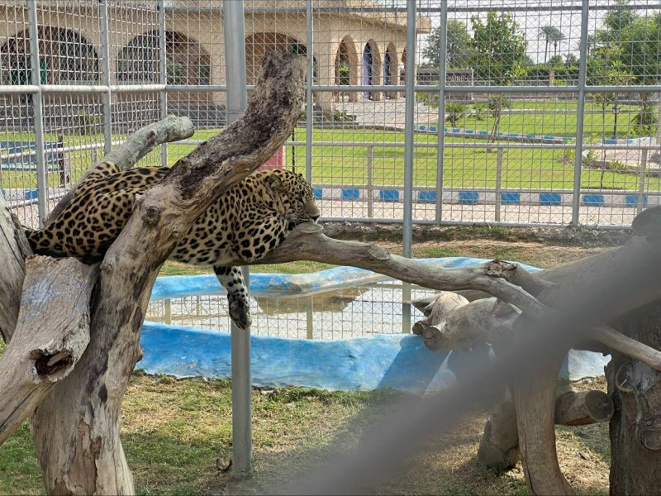

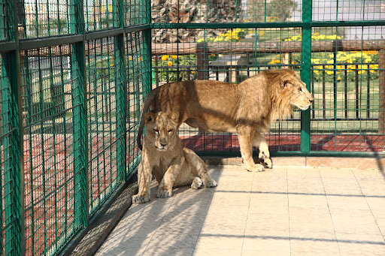

Animals List

he Multan Zoo is home to around 200-250 animals across various species. While it is smaller compared to larger zoos in Pakistan, it hosts a variety of animals.

Notable exhibits include:

Lions

Deer

tigers

Reptiles

Crocodiles

Snakes

cheetah

Turtle

Monkeys

Address & Contact

Address: Multan Zoo, Mumtazabad, Multan, Punjab, Pakistan For questions related to visiting, opening times, directions, accessibility, or other general information, you can visit their [Support Centre](https://wildlife.punjab.gov.pk).

Email: For specific enquiries

you can fill out the contact form available on their (info@wildlife.punjab.gov.pk).

Phone: For urgent enquiries, you can call their Supporter Contact team at 0344 225 1826.

For the most accurate and up-to-date information, it's recommended to visit the [official Multan Zoo website](https://wildlife.punjab.gov.pk).